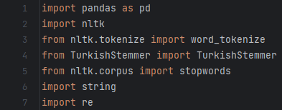

* Importing the necessary libraries and modules required for text preprocessing.



* This line reads an Excel file (“FileName.xlsx”) into a pandas DataFrame called “df”.



* This creates an instance of the TurkishStemmer class from the “TurkishStemmer” modüle, which will be used for stemming fort he Turkish text.

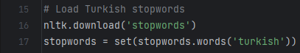

* This code downloads the Turkish stopwords from the NLTK library and stores them in a set called “stopwords”. Stopwords are commonly used words (such as articles, pronouns, etc.) that are often removed during text preprocessing.

The code then defines multiple preprocessing functions (“preprocessing1111, preprocess1110”, “preprocess1101”, etc.), each corresponding to a specific scenario number. These functions take a text input and perform various preprocessing steps based on the scenario requirements.

The common preprocessing steps performed in each function are:

1. Lowercasing the text: The “lower()” method is used to convert the text to lowercase.
2. Removing emoticons: The “re.sub()” function is used with a regular expression to remove emoticons from the text.
3. Removing punctuation: The “str.translate()” method is used with “string.punctuation” to remove punctuation marks from the text.
4. Tokenizing the text: The “Word_tokenize()” function from NLTK is used to tokenize the text into individual words.
5. Stemming: The TurkishStemmer instance “stemmer” is used to perform stemming on the tokens. Stemming reduces words to their base or root form.
6. Removing stopwords: The stopwords loaded earlier are filtered out from the tokens.
7. Joining tokens: The processed tokens are joined back into a single string using the “join()” method.



* This line applies the “GivenFunctionName” function to the “Comment” column of the DataFrame and stores the preprocessed text in a new column called “Preprocessed Text”.



* Finally, the updated DataFrame with the preprocessed text is saved to a new Excel file called “Given File Name.xlsx”

This provided documentation assumes that the code has been written correctly and that the input file exists in the same directory as the script. Make sure to replace the filenames and column names as needed in your specific use case.